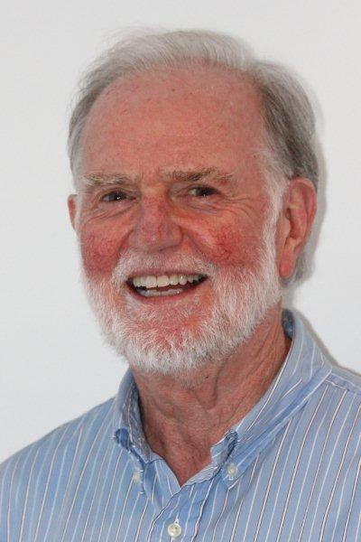
Derek Holton: A Short Bio
I suppose that I am a mathematics educator. On balance, I am more of a mathematician who educates. Over the last 50-odd years I have taught in various universities and my last 23 academic years were spent as a Professor of Pure Mathematics (at the University of Otago in New Zealand). Despite this major drawback, I am registered as a teacher with the Victorian Institute of Teaching, so at any moment I could launch a new career as a real teacher.
Throughout my salaried years I tried not to lecture. This isn’t always possible to do. The amount and depth of the material that is required in a university course, or any other course for that matter, often demands that material be transmitted. But whenever I thought that students could participate in developing their own learning that’s the way I tried to move. And in tutorials the students were the ones who had to work on the maths and think about what had to be done. My job was to scaffold them in the right direction.
My teaching was also guided by the research maths that I did. When I was doing research there was no one to tell me how it should be done and what the result might be. Every new theorem had to be dragged out of the subject matter. In the process I learnt how to learn independently. Well not completely independently because the vast majority of my work was done in association with other researchers. So I tried to encourage my students to learn how to learn by themselves and with others partly because that is the way maths works and partly because when students are in jobs they may well have to invent or discover material for themselves or with others.
There is certainly material that students will need to know from their education, whatever that is, but progress in society needs people who will also know how to develop new ideas.
Now actually this discovery stuff has only a little to do with maths. It’s part of human life. I love music. Musicians have to know how to play their instruments, but they also have to know how to improvise, develop new approaches and compose new music. It’s what makes their playing interesting, exciting even and music enjoyable. I love the circus. But the juggler who can only juggle isn’t going to be hired for the major circuses. She/he has to learn how to juggle one more object than any of their competitors; they have to learn to do it on their backs, dangling in the air or being turned around inside a sphere. These are the kind of jugglers circuses and audiences want. These are the kind of people that will improve our lives in some way.
So that is why I try to develop problem solving in people.
On the home front my wife and I have been married for over 50 years, we have 4 children, 5 grandchildren and a cat that can problem solve. And you have to realise that animals can problem solve too. It’s got nothing special to do with maths, but maths is a good place to learn it because you can often cut out a lot of extraneous material to concentrate on and learn the process.
Derek Holton

